Pokémon images



In this project you will train a computer to predict the type of Pokémon based on how they look.

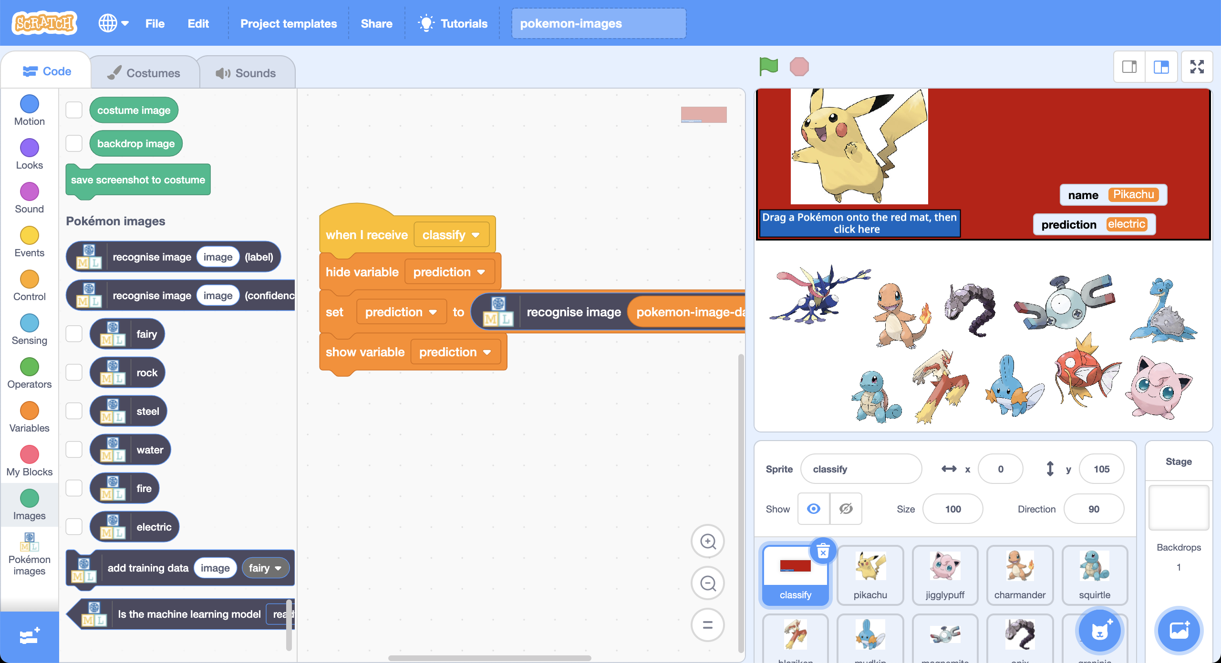

This project worksheet is licensed under a Creative Commons Attribution Non-Commercial Share-Alike License

http://creativecommons.org/licenses/by-nc-sa/4.0/

This is Pikachu.

Pikachu is an **electric** Pokémon.

There are lots of different types of Pokémon.

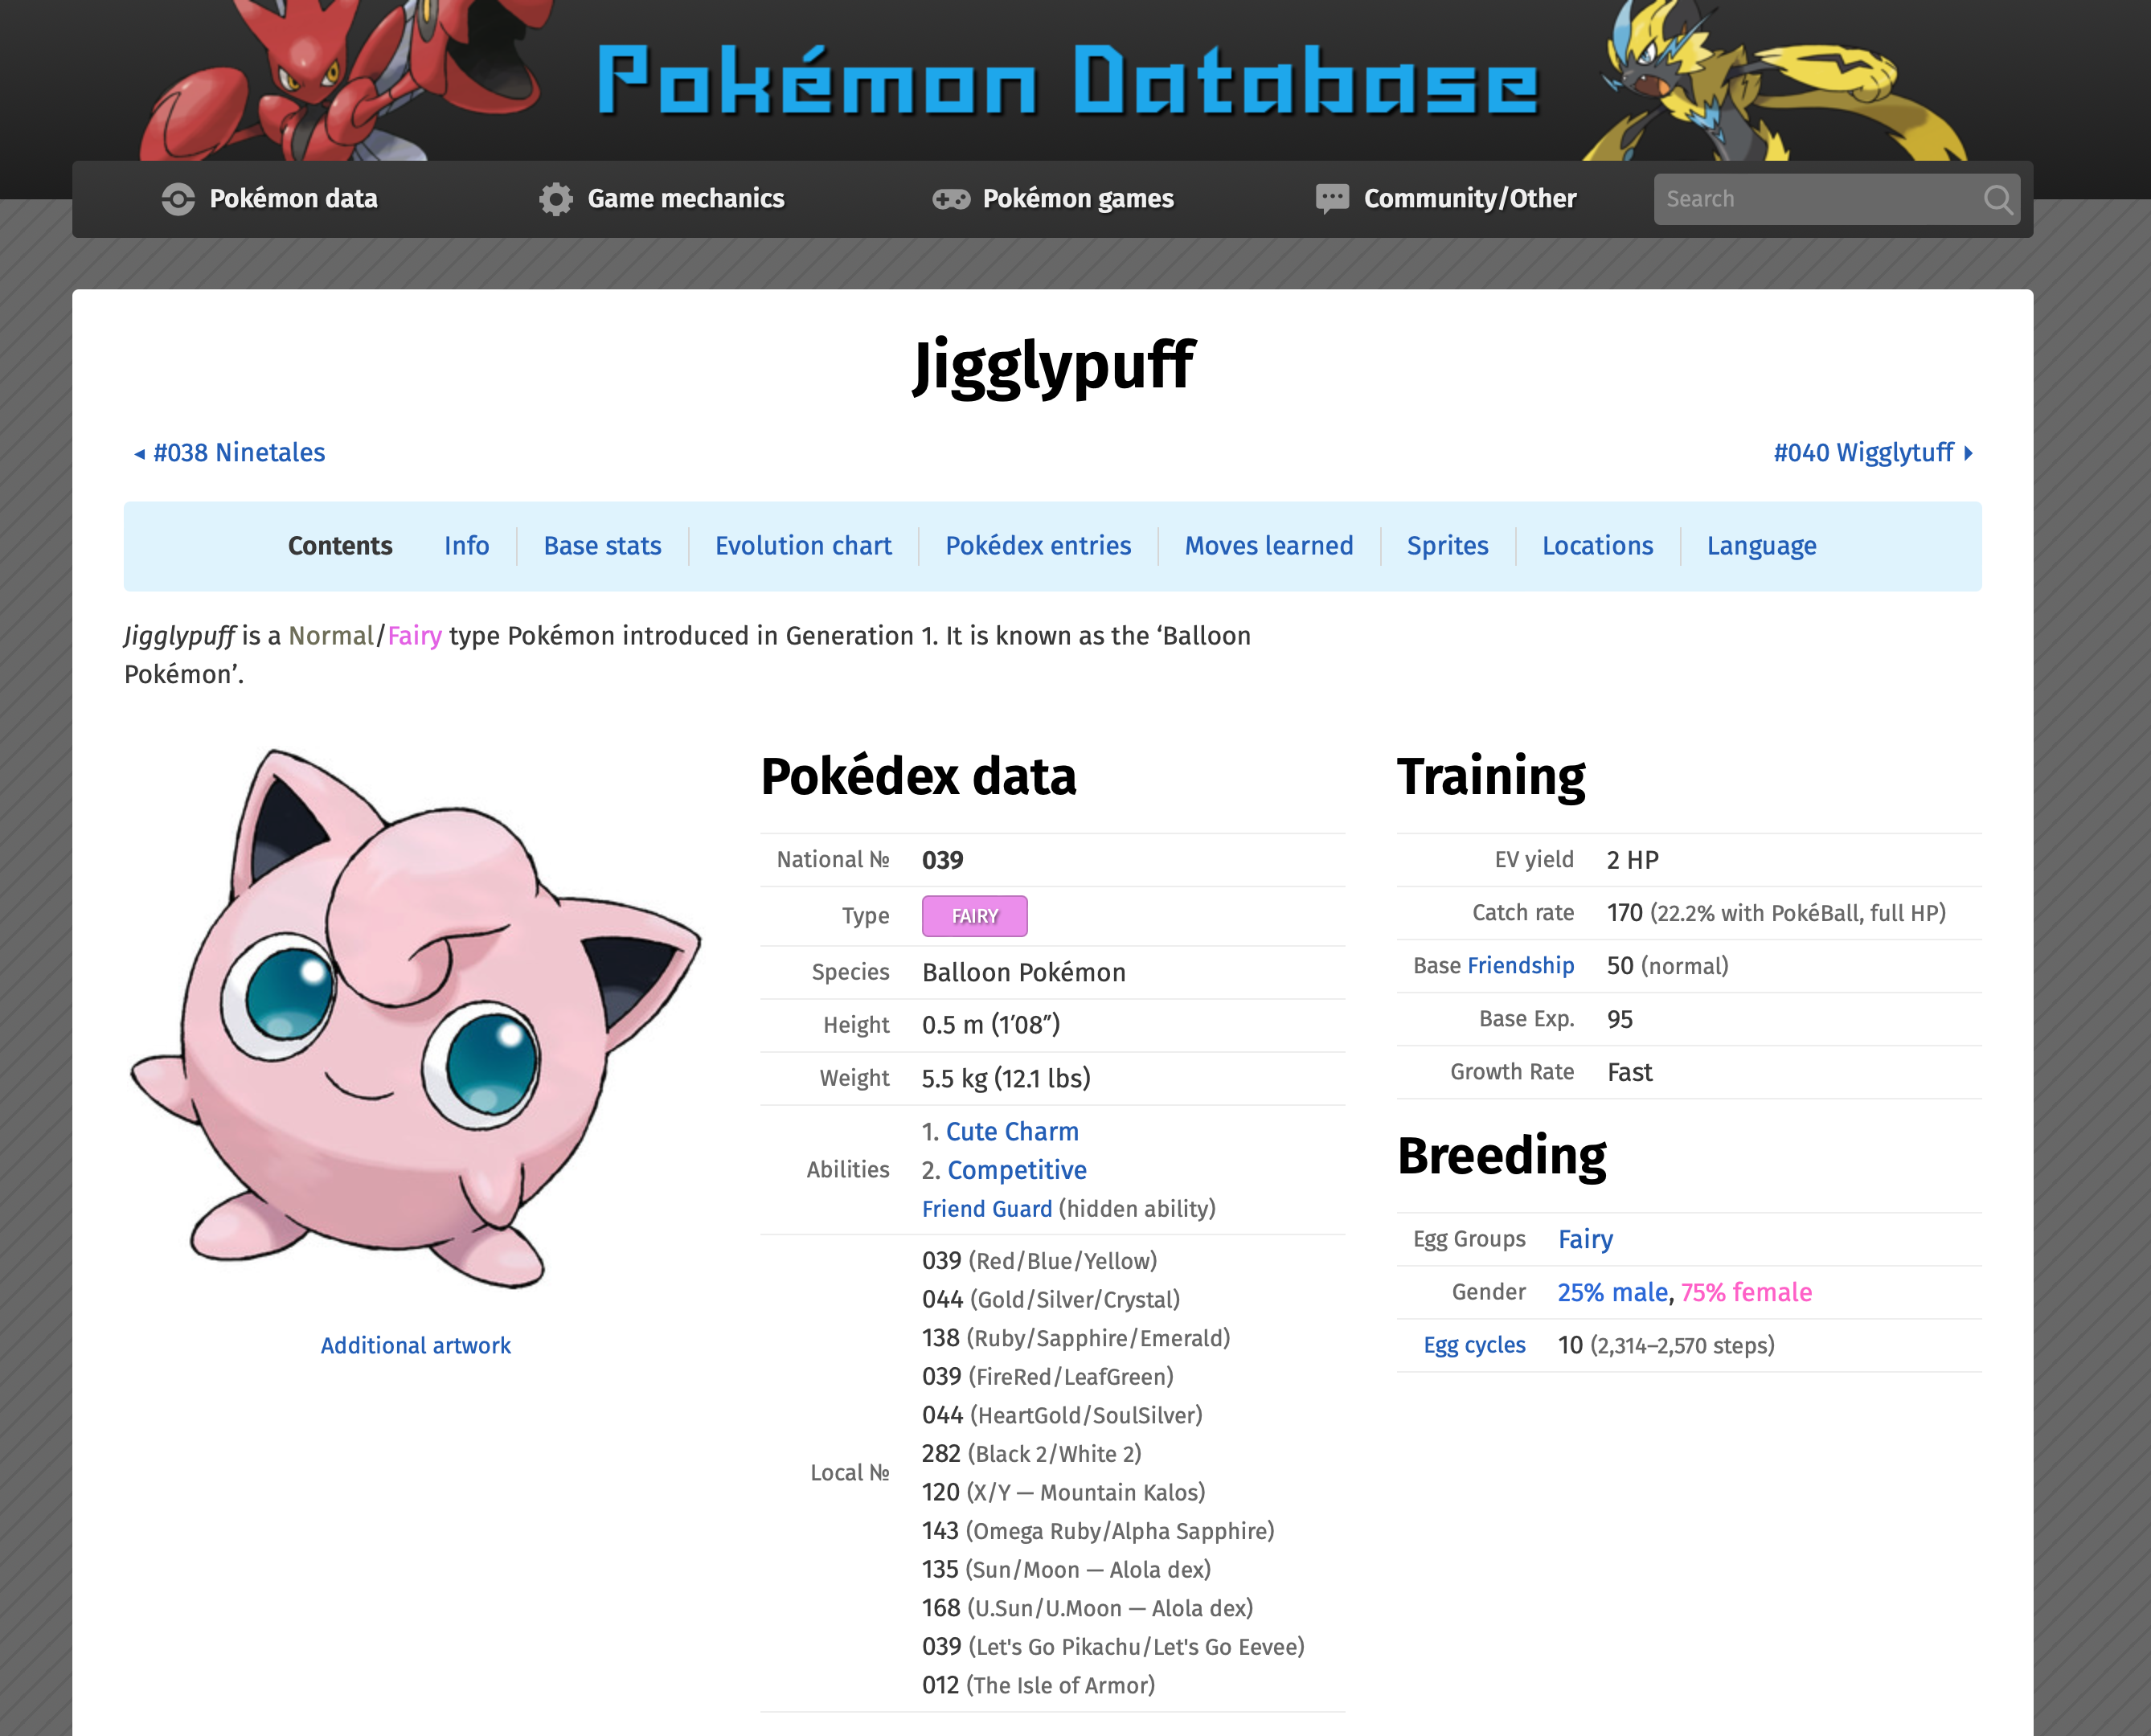

Jigglypuff is a **fairy** Pokémon.

Check the types of other Pokémon in the Pokémon database at https://pokemondb.net

The types of Pokémon are:

* Normal
* Grass
* Ground
* Rock
* Fire
* Ice
* Flying
* Ghost
* Steel
* Water
* Fighting
* Psychic
* Dragon
* Fairy
* Electric
* Poison
* Bug
* Dark

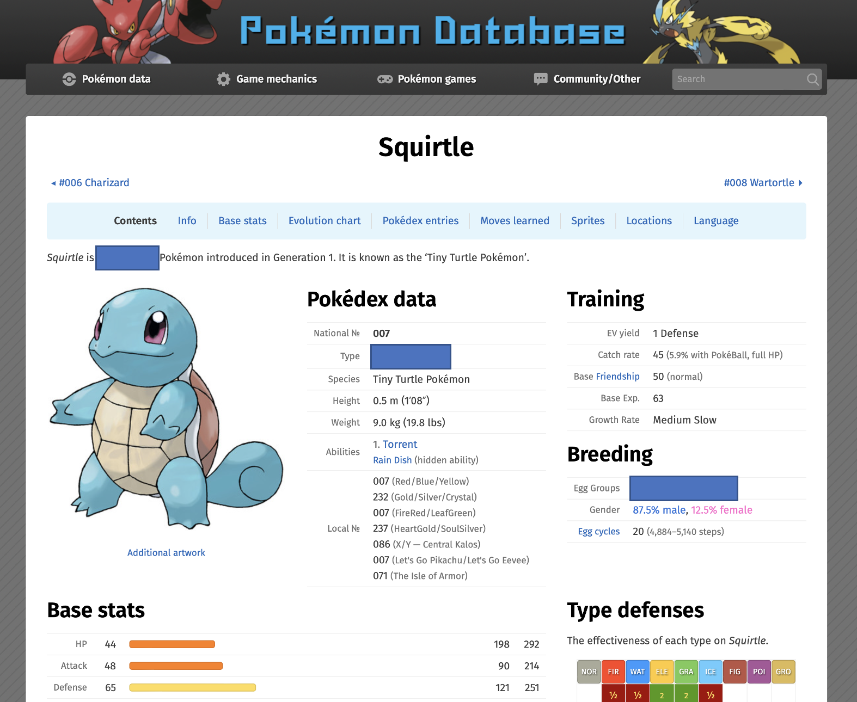

What type of Pokémon is Squirtle?

Try to guess.

What information do you think you could use to guess the type?

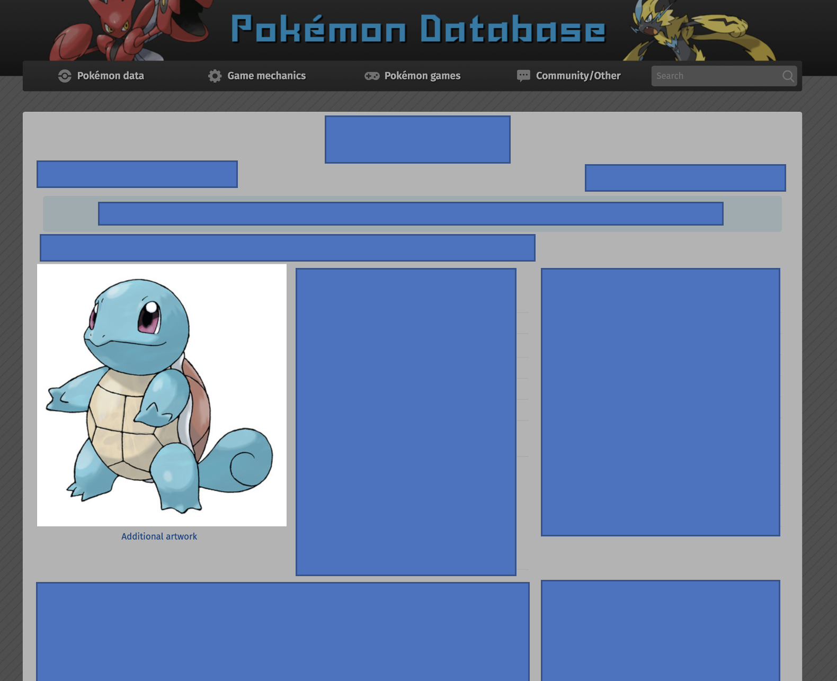Would you use the way that it **looks**?

Do you think the colours and the shapes would give you a good clue for what the type is?

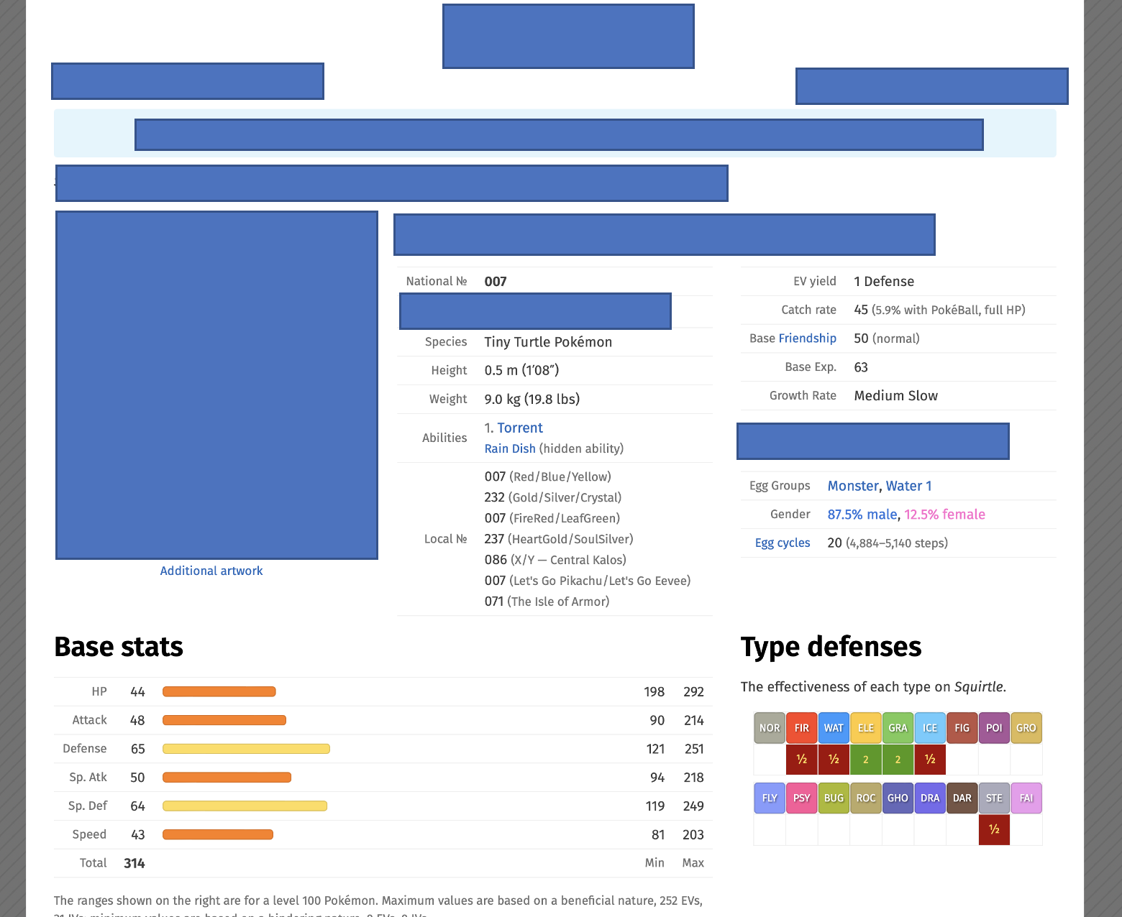

Would you use the **statistics** that describe the Pokémon’s size, abilities, and fighting style?

Do you think those numbers would give you a good clue for what the type is?

Neither is perfect.

There aren’t rules. But we can learn what they have in common and use this to make a guess.

Computers can do this. Computers can work without relying on rules, by learning what things have in common and using this to make predictions.

We call this type of computing **Machine Learning**.

In this project, you will train a computer to be able to predict the type of a Pokémon based on how it looks, by training it with pictures of a hundred example Pokémon.

To make things a little quicker, we won’t train the computer to recognise every type of Pokémon, we’ll just focus on six of the types as an example.

1. Go to <https://machinelearningforkids.co.uk/> in a web browser
2. Click on “**Get started**”
3. Click on “**Try it now**”
4. Click on “**Copy template**” 
5. Click on **“Pokémon images**”   
   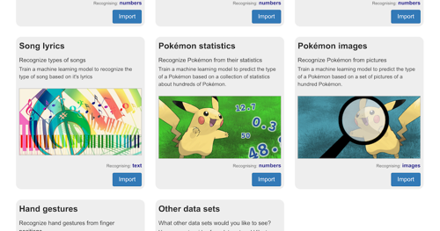
6. Click on “**STORE ON YOUR COMPUTER**”
7. Click on “**Pokémon images**”  
   
8. Click on “**Train**”  
   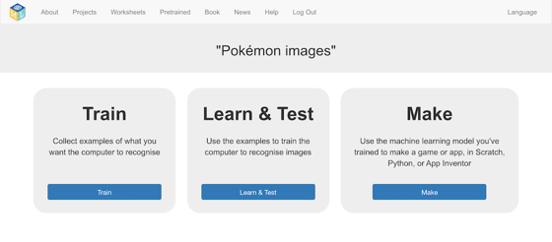
9. Look through the training images   
   *These are the images of over a hundred Pokémon that you will use to train the computer with*.
10. Click on “**Back to project**”
11. Click on “**Learn & Test**”
12. Click on “**Train new machine learning model**”  
    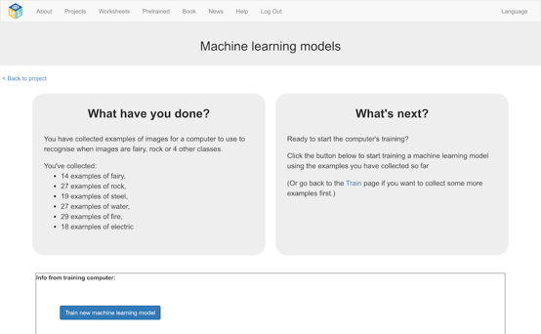
13. Click on “**Back to project**”
14. Click on “**Make**”
15. Click on “**Scratch 3**”  
    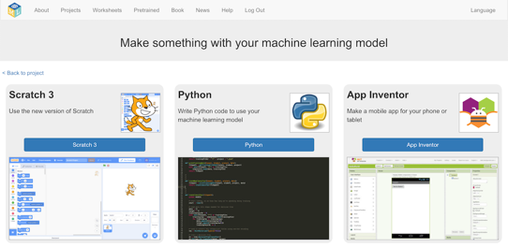
16. Click on “**Open in Scratch 3**”  
    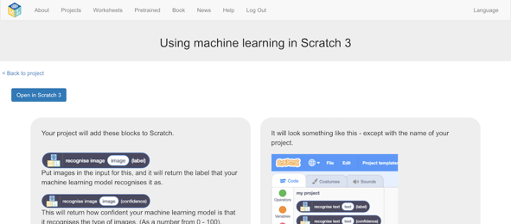
17. Click on “**Project templates**”
18. Click on “**Pokemon images**”
19. Click on the “**classify**” sprite  
    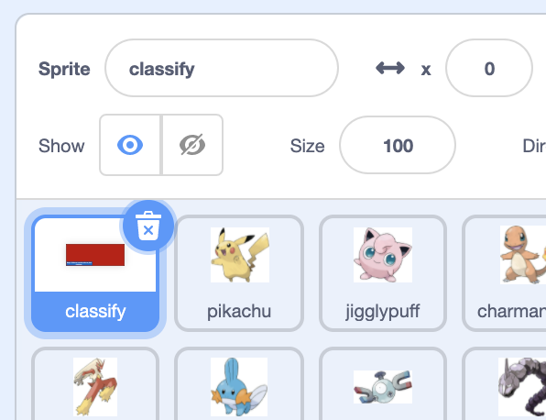
20. Find the “**when I receive classify**” code  
    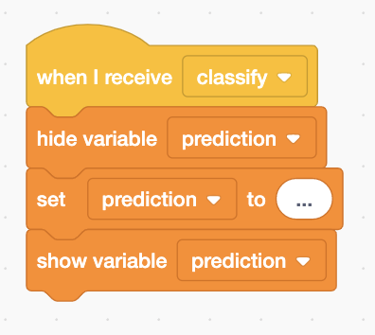
21. Update the code to use your machine learning model  
    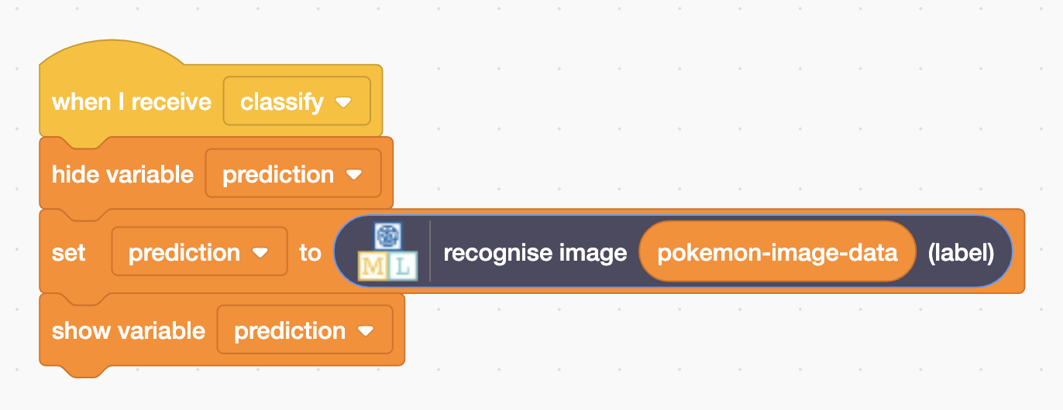
22. Click on the “**full-screen**” button  
    
23. Click on the “**Green Flag**”  
    

**What have you done so far?**

You’ve used pictures of a random sample of a hundred Pokémon to train a computer to be able to predict the type of a Pokémon from a picture. You’ve set up a Scratch project that can use your machine learning model.

Next, you’ll test your model to see how good it is at guessing the type of new Pokémon.

Images of **six** Pokémon have been prepared for you in the Scratch project.

All six of these are Pokémon that were **not** included in the training data you used to train your machine learning model.

**Why do you think this is important?**

If you want to test with more Pokémon, you can find more images at https://pokemondb.net

Try testing your model to see what mistakes it makes.

If you find a mistake, look at your training examples again to try and think of a reason for the mistake.

Different models will behave differently, so your results may not be the same as mine. But here are mistakes I noticed in my testing.

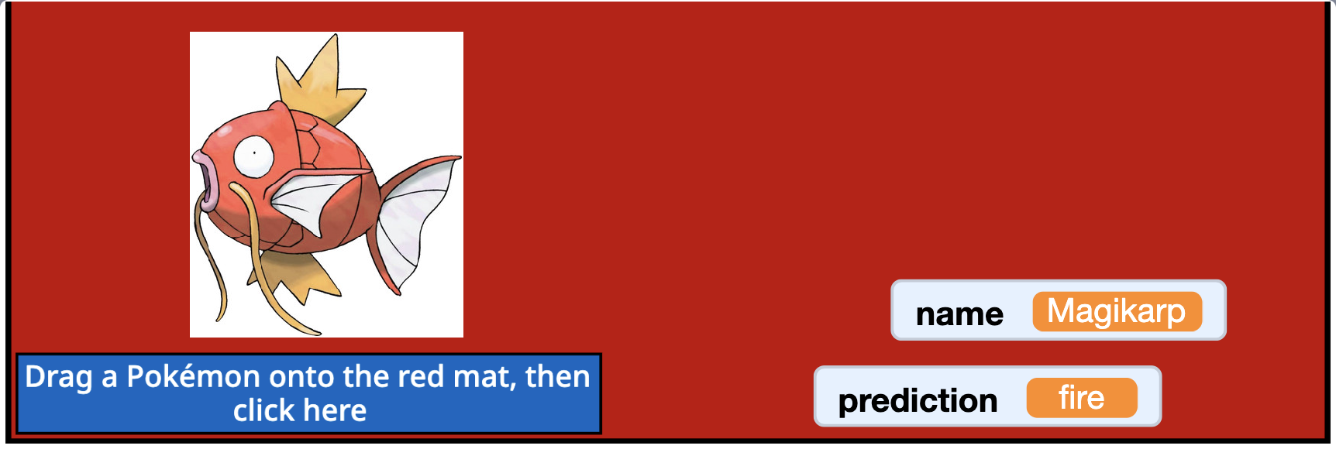

Magikarp is a **water** Pokémon, but my model guessed it was a fire type.

Why do you think it might have done that?

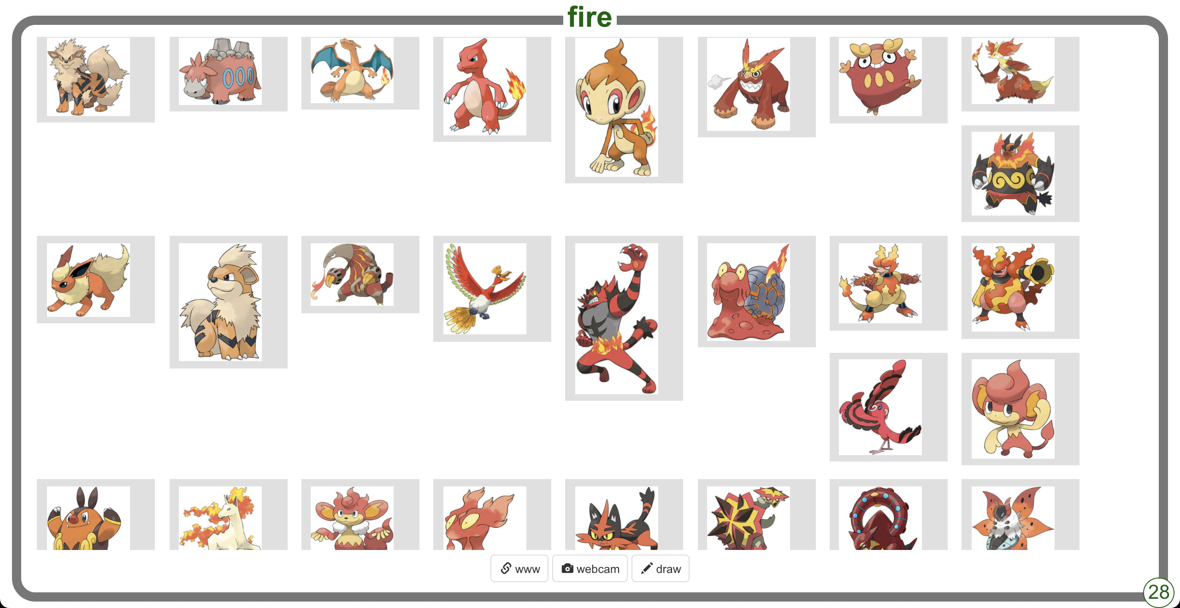

It might be the colour. Lots of the fire Pokémon have a lot of red and orange in them, so it’s possible that my machine learning model learned to associate red and orange with fire.

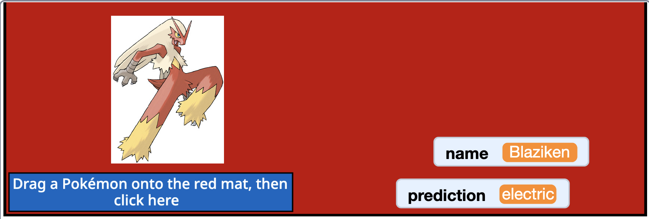

Blaziken is a **fire** Pokémon, but my model guessed it was an electric type.

Why do you think it might have done that?

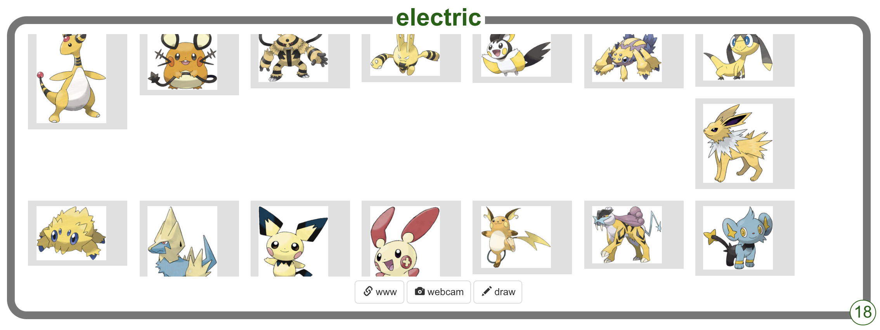

It could be the shapes. Lots of the electric Pokémon have spiky jagged yellow electric bolt-style shapes in them, so it’s possible that my machine learning model learned to associate spiky yellow shapes with electric.

**What have you learned?**

Machine learning models are not perfect.

They can learn to spot patterns, and they can use those patterns to makes predictions. Those predictions are often correct. But sometimes they will be wrong.

Understanding why a machine learning model gives a wrong answer is difficult. Machine learning systems often just give you their prediction, without an explanation for why they came up with that answer. We can try to guess for possible reasons by comparing the tests with the data we used for training.

Pokémon images used in this activity came from

https://www.kaggle.com/vishalsubbiah/pokemon-images-and-types

Other screenshots used in this activity came from

https://pokemondb.net

©2022 Pokémon. ©1995 - 2022 Nintendo/Creatures Inc./GAME FREAK inc. TM, ®Nintendo

**Ideas and Extensions**

Now that you’ve finished, why not give one of these ideas a try?

Or come up with one of your own?

**Design your own Pokémon!**

Try drawing your own Pokémon. What type does your machine learning model think it is?

You can draw a Pokémon in Scratch using the drawing tools for a new sprite.

Or you can draw it with pen and paper, and then use the camera tool to create a new costume in Scratch from a webcam photo of your drawing.